UGANDA MARTYRS UNIVERSITY-NKOZI



**FACULTY OF SCIENCE**

**WEB DEVELOPMENT COURSEWORK**

**TOURISM IN UGANDA**

**GROUP G**

**GROUP G MEMBERS;**

1. WALAKIRA CHRISTOPHER – 2025-B071-10970
2. RESTY NAKALWA MUKASA – 2025-B291-11276
3. LUSWATA DEOGRATIOUS – 2025-B201-12129
4. MULUMBA ROGERS – 2025-B201-13117
5. MPAGAZI MICHAEL JOSEPH – 2025-B221-11593
6. AL-MAHAD BIN –

**INNOVATORS AND THEIR ROLES;**

1. WALAKIRA CHRISTOPHER – SERVICES PAGE DEVELOPER
2. RESTY NAKALWA MUKASA – CONTACTS PAGE DEVELOPER
3. LUSWATA DEOGRATIOUS – DESTINATIONS PAGE DEVELOPER
4. MULUMBA ROGERS – HOME PAGE DEVELOPER
5. MPANGAZI MICHAEL – ABOUT PAGE DEVELOPER
6. AL-MAHAD BIN –

**WEBSITE TOPIC AND PURPOSE**

“Tourism in Uganda” aims at promoting beautiful tourist attractions like wildlife, culture and scenic landscapes not forgetting the vegetation cover in different parts of Uganda. This website encourages both local and international tourists to visit different attractions by providing information, images and contact options.

**FUNCTIONS AND DESCRIPTION OF EACH PAGE**

1. **HOME PAGE:** This introduces visitors to Uganda’s tourism with a hero image, brief descriptions and highlights of some attractions.
2. **ABOUT PAGE:** This provides the background information on the website’s mission and introduces the development team
3. **DESTINATION PAGE:** this page displays Uganda’s popular tourist destinations with descriptions and images using HTML and CSS grid layout.
4. **CONTACT PAGE:** This contains a feedback form with Javascript validation allowing visitors to send messages

**PROGRAMS USED**

* HTML – structuring the webpages
* CSS – styling and layout consistency across pages
* JAVASCRIPT – for interactivity (form validation and alerts)

**SCREENSHOTS OF EACH PAGE**

1. **HOME PAGE**

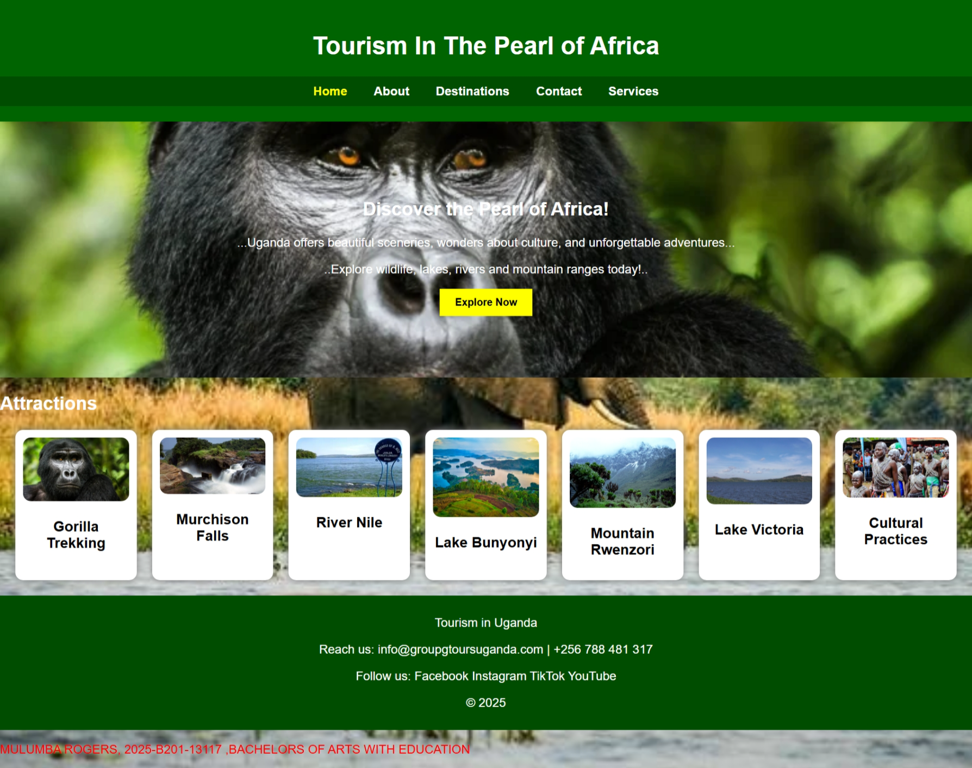

1. **ABOUT PAGE**

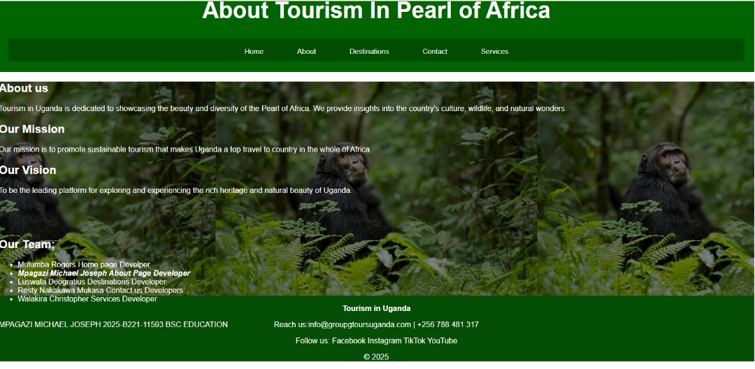

1. **CONTACT PAGE**

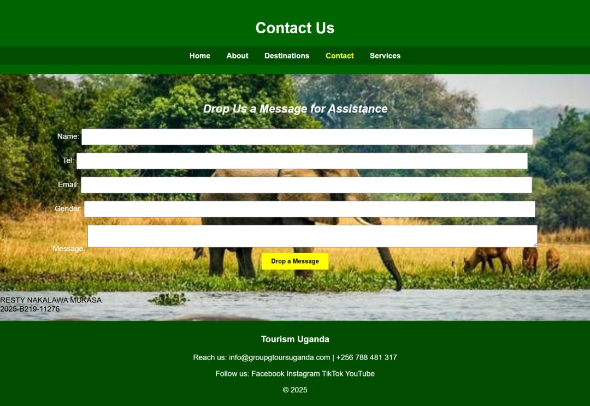

1. **DESTINATIONS PAGE**

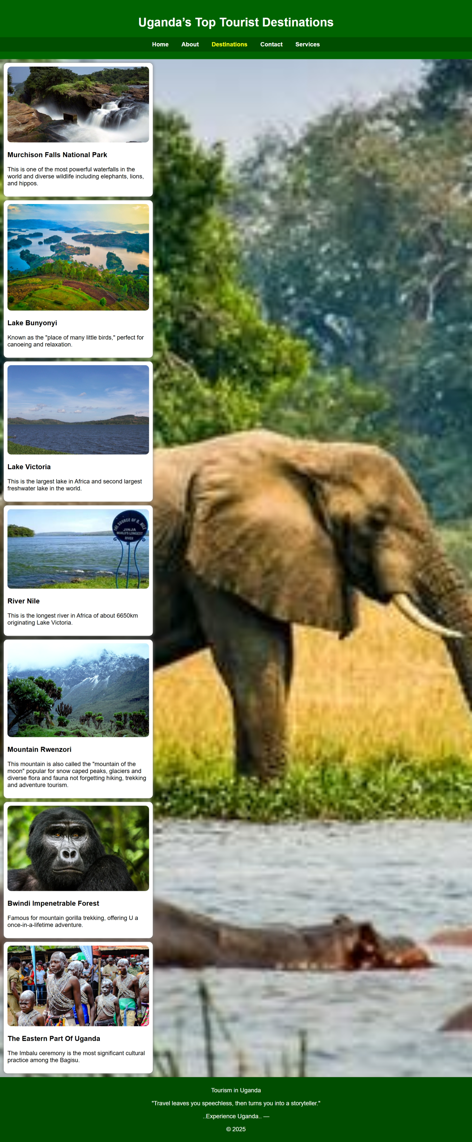

1. **SERVICES**

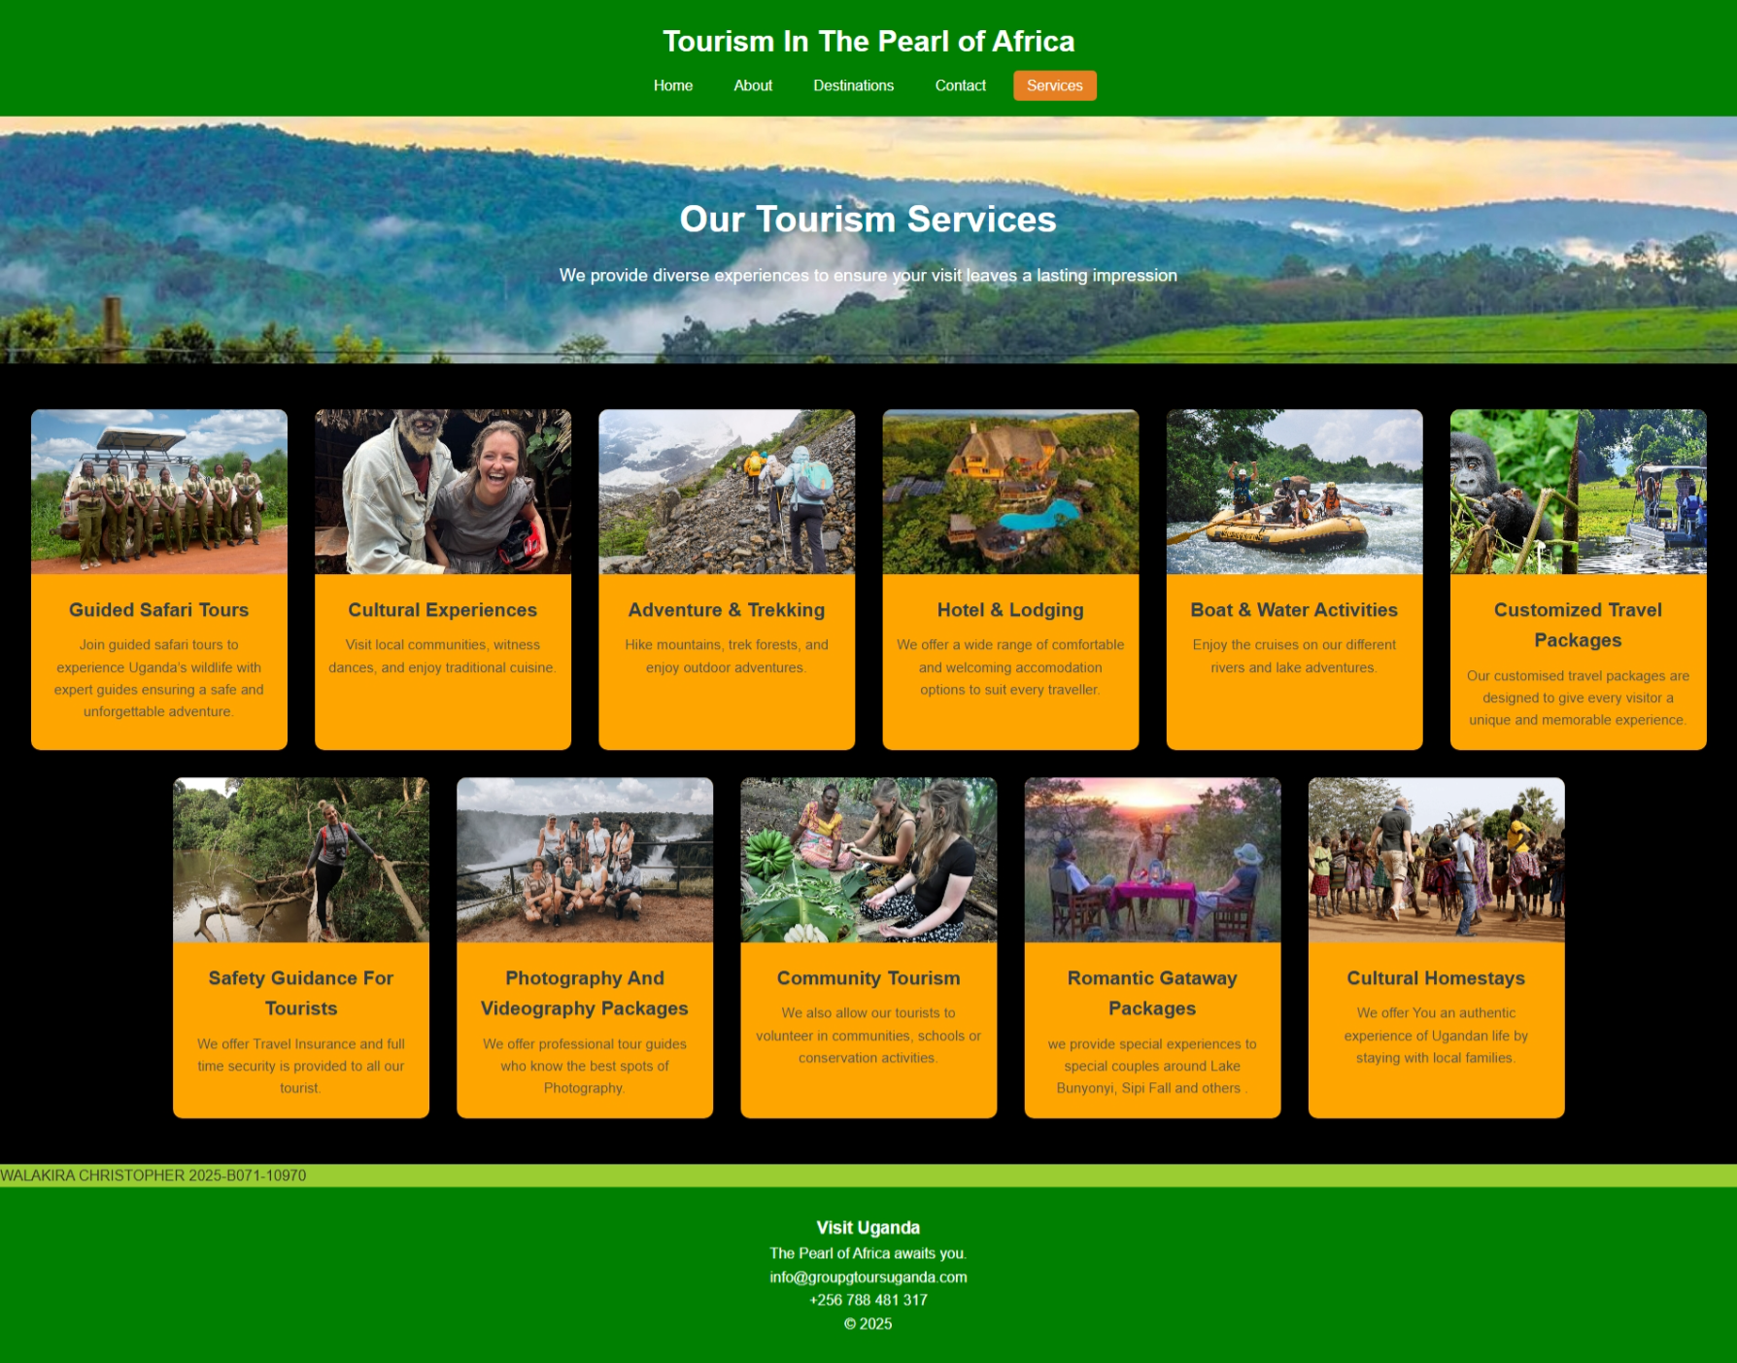

**CHALLENGES FACED**

During the process of developing that website, we faced challenges missing out codes, a problem of linking multiple folders correctly and maintaining a consistent layout throughout the website

**LESSONS LEARNED**

We managed to learn how to use relative file paths, CSS and JS files link sharing

We also managed to host the project on GitHub Pages

The unity amongst us improved our understanding of HTML, CSS and JAVASCRIPT integration.

By: Web Innovators (Tourism in Uganda)

GROUP G